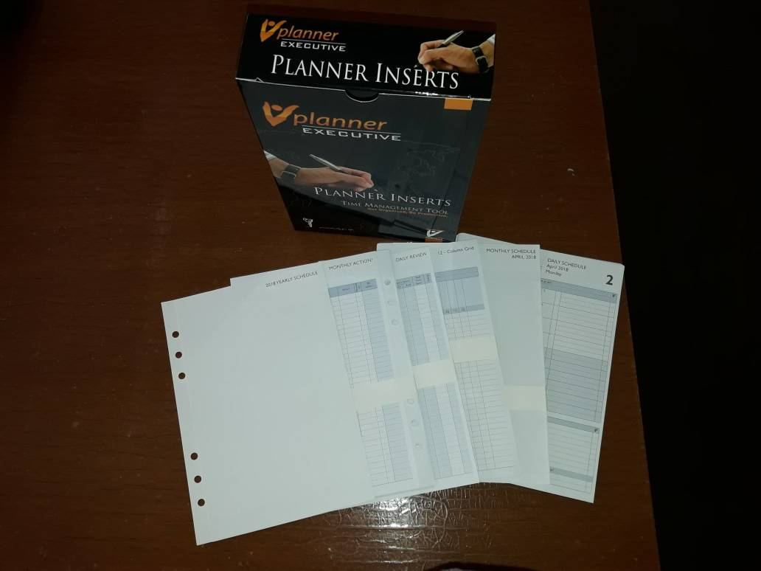ANNUAL REFILL 2026 **ORDER** FORM

Name: _____________________________________________________________________________________

Company: _______________________________­­­­­­­­­­­­­­­­­­­­____________________________________________________

Address: _____________________________________________________________________________________________

_____________________________________________________________ Postcode: _____________________

Tel: ____________________ Fax: ________________________ Handphone: _________________________

Email: _______________________________________________________________________________________

# Yes! I am interested in the 2026 Annual Refill at RM150.00* / SGD75.00 (for delivery to Singapore)

Quantity ______________ sets

# 

# I am enclosing a cheque for RM ___________ Cheque No: __________________

# Made payable to VENTRAX SELF DISCOVERY SOLUTIONS

# ­­­­­­­­

Please make online payment to **Affin Bank Berhad (A/C No: 100200251685)**

***\*Please add RM15.00 per set for delivery to East Malaysia (Sabah/Sarawak)***

**Administration Details**

Please email the order form and forward the payment to **VENTRAX SELF DISCOVERY SOLUTIONS 202003203874 (CA0305503-X)**, No. 27-3B Jalan Tasik Prima 5/2, Block C Prima Biz Hub, Taman Tasik Prima, 47150 Puchong, Selangor Darul Ehsan, Tel: 603-8211 1338/012-951 3309, Email: [celyn@ventrax.com.my](mailto:celyn@ventrax.com.my), Website: [www.ventrax.com.my](http://www.ventrax.com.my)

*Prices are subject to change without prior notice.*